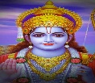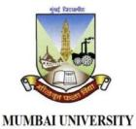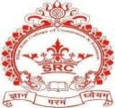

*Jan Seva Sangh Sanchlit*

Shri Ram college of Commerce

(Affiliated to University of Mumbai)

NAAC ACCREDITED BY “B”

ISO 9001:2015 Certified

Ayodhyam Intercollegiate Fest Feb 2025

Name of Event : BGMI Date : 07/02/2025 Total participants 84

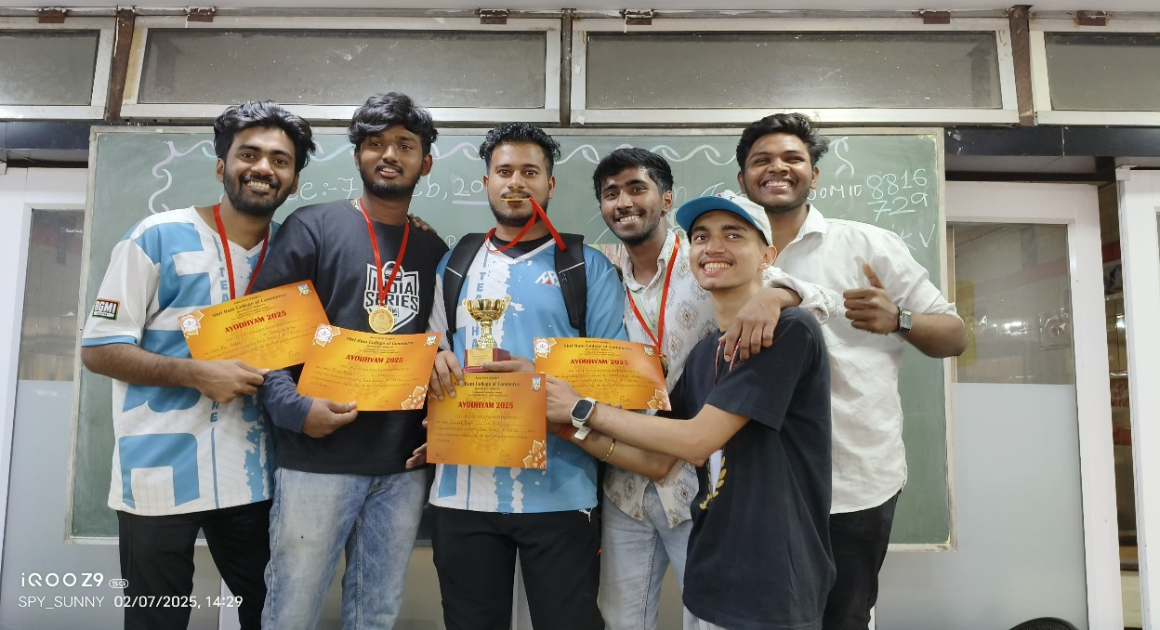PHOTOS

**First Prize winner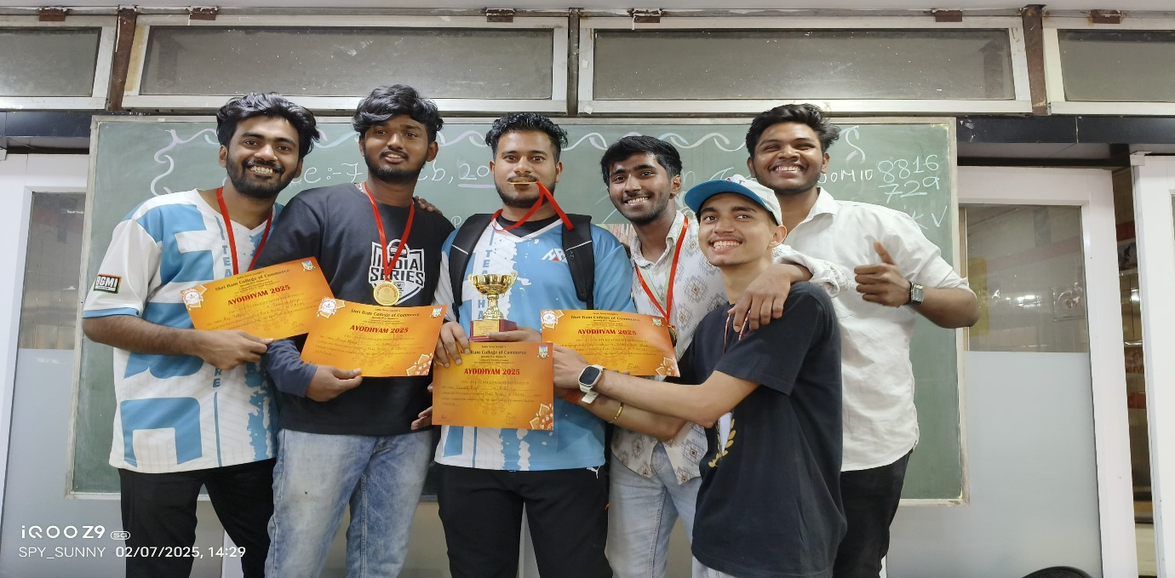rize Winner**

**Second Prize winner****rize Winner**

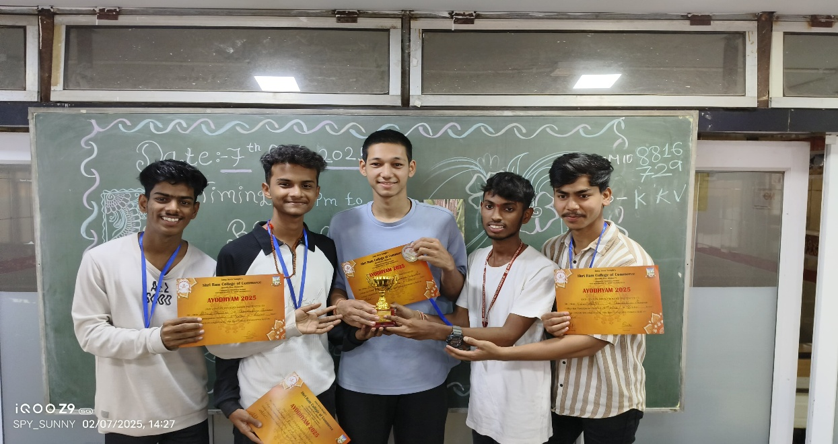

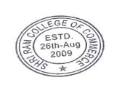

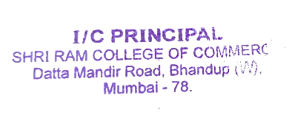

Gen. Sec. :Dr. Aun Mule (Ph.d., D.H.E., M.com) M.D.:Dr. Mansi Mule (Ph.D. M.B.A, M.Com, B.Ed)

Datta Mandir Road, Subhash Road, Bhandup West, Mumbai Maharashtra 400 078, Tel:+9769317255,9769457128, Fax 022 2566 6643

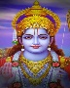

*Jan Seva Sangh Sanchlit*

Shri Ram college of Commerce

(Affiliated to University of Mumbai)

NAAC ACCREDITED BY “B”

ISO 9001:2015 Certified

Ayodhyam Intercollegiate Fest Feb 2025

Name of Event : BGMI Date : 07/02/2025 Total participants 84

PHOTOS

**Third Prize winner****rize Winner**

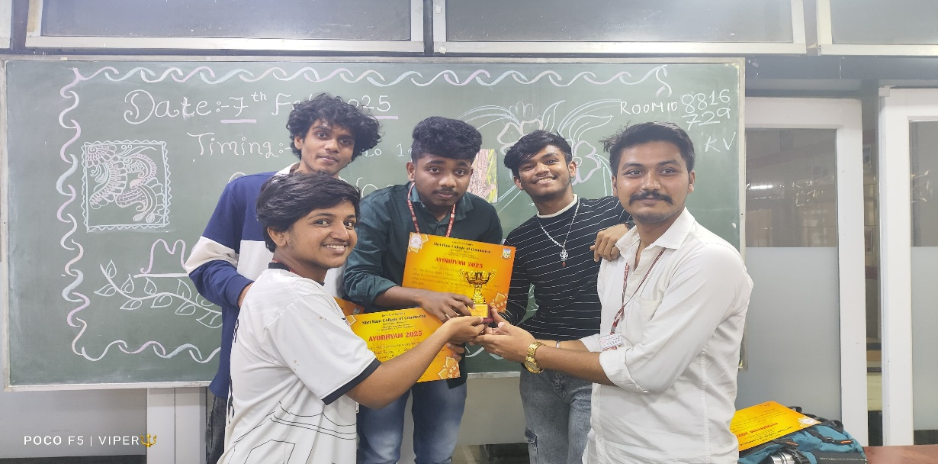

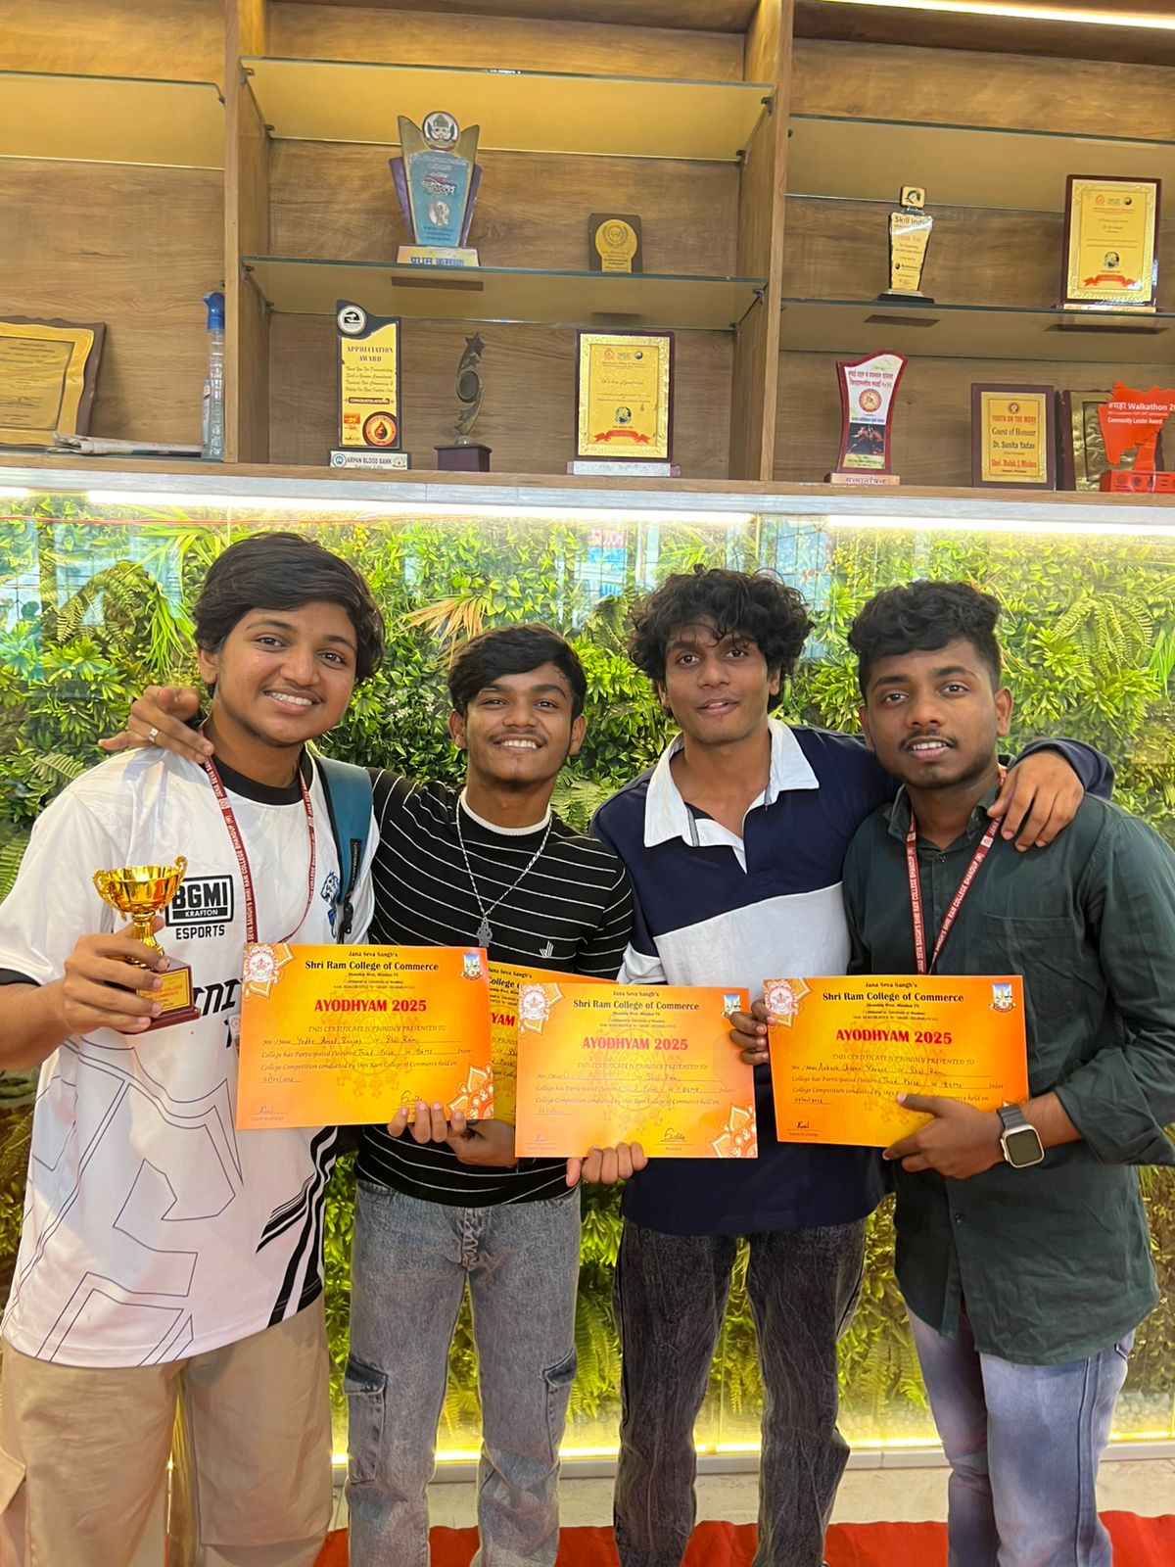



Gen. Sec. :Dr. Aun Mule (Ph.d., D.H.E., M.com) M.D.:Dr. Mansi Mule (Ph.D. M.B.A, M.Com, B.Ed)

Datta Mandir Road, Subhash Road, Bhandup West, Mumbai Maharashtra 400 078, Tel:+9769317255,9769457128, Fax 022 2566 6643





*Jan Seva Sangh Sanchlit*

Shri Ram college of Commerce

(Affiliated to University of Mumbai)

NAAC ACCREDITED BY “B”

ISO 9001:2015 Certified

Ayodhyam Intercollegiate Fest Feb 2025

Name of Event : BGMI Date : 07/02/2025 Total participants 84

Action photos

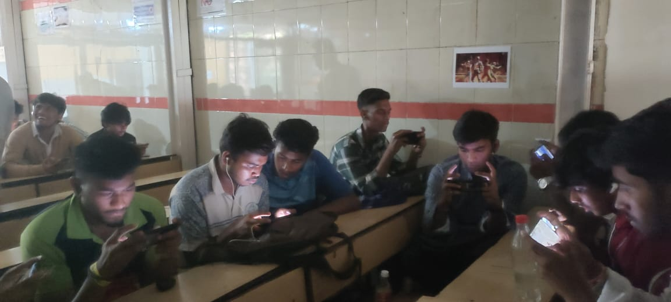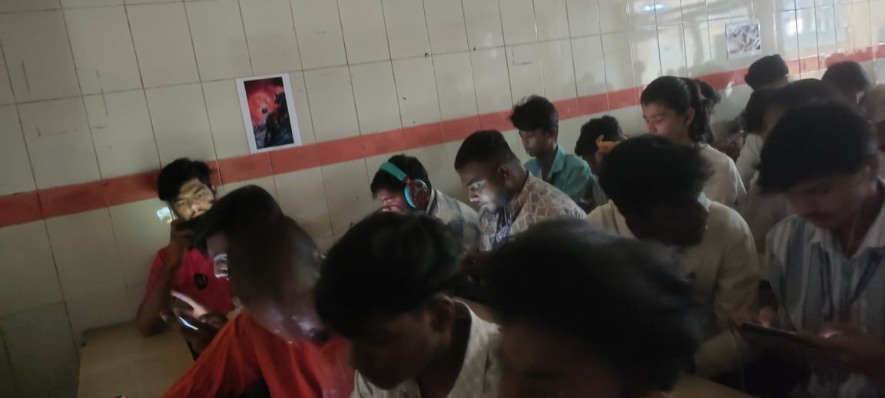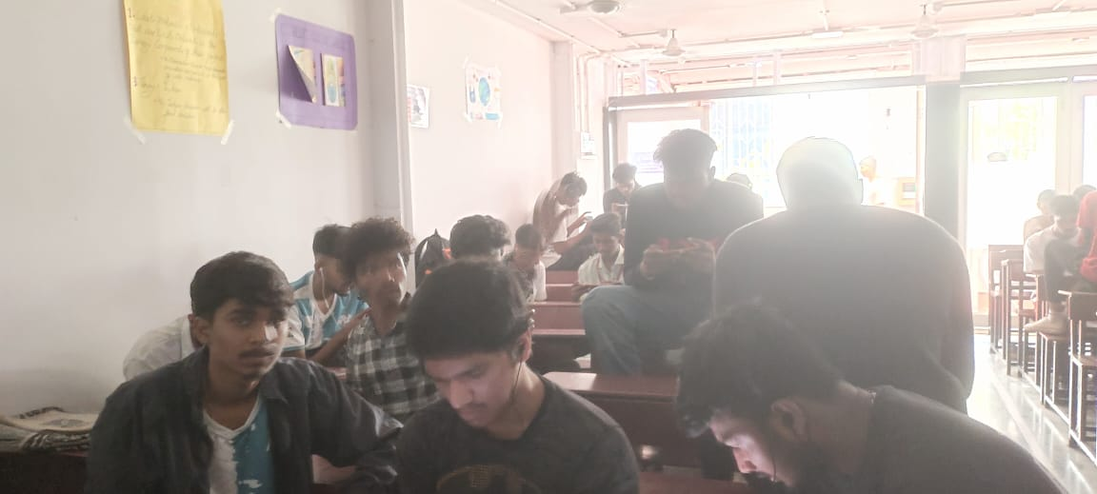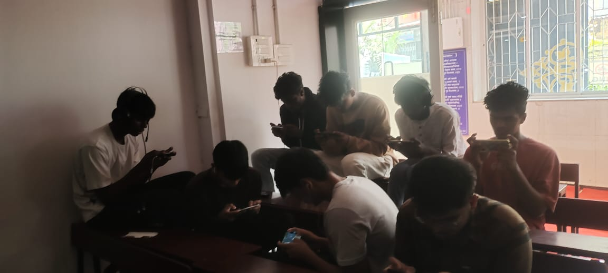



Gen. Sec. :Dr. Aun Mule (Ph.d., D.H.E., M.com) M.D.:Dr. Mansi Mule (Ph.D. M.B.A, M.Com, B.Ed)

Datta Mandir Road, Subhash Road, Bhandup West, Mumbai Maharashtra 400 078, Tel:+9769317255,9769457128, Fax 022 2566 6643



*Jan Seva Sangh Sanchlit*

Shri Ram college of Commerce

(Affiliated to University of Mumbai)

NAAC ACCREDITED BY “B”

ISO 9001:2015 Certified

Ayodhyam Intercollegiate Fest Feb 2025

**Report**

**Date:** 7th February 2025  
**Time:** 9:00 AM

Venue: Block no 02 / 03

Shri Ram College of Commerce had organized a Fest called “Ayodhyam” – An Intercollegiate Fest on 07/02/2025 and 08/02/2025. Under Ayodhyam college had organized the event “BGMI” on 07/02/2025 at 9:00am. It was an Intercollegiate event. Students from other colleges had participated in this event. Total **84** students participants had attended this event. Volunteers conducted this event in three rounds.

Winners of this event :-

1st Team

i)Saurabh Singh from R.J. college Thane

ii) Nikhil Narkar from S.P.D.C. college

iii)Surya Kumar from V.P.M. college Thane

iv)Raj Yadav from Somaiya college Vidyavihar

2nd Team

i)Shivam Chauhan from Chandrabhan Sharma college Powai

ii)Nitesh Singh from Somaiya college Vidyavihar

iii)Abhijit Kahar from Chandrabhan Sharma college Powai

iv)Chaitnya Dumbre from Chandrabhan Sharma college Powai

3rd Team

i)Chetan Ankush From Shri Ram college Bhandup

ii)Amol Yedke From Shri Ram college Bhandup

iii)Vighnesh Choudhary From Shri Ram college Bhandup

iv) Piyush Mulye From Parag College Bhandup

Teacher in charge : Mrs.

Sunanda Mulgund

Miss. Alsheefa Shaikh

Mrs. Aparna Patil



Gen. Sec. :Dr. Aun Mule (Ph.d., D.H.E., M.com) M.D.:Dr. Mansi Mule (Ph.D. M.B.A, M.Com, B.Ed)

Datta Mandir Road, Subhash Road, Bhandup West, Mumbai Maharashtra 400 078, Tel:+9769317255,9769457128, Fax 022 2566 6643